## **Write the python program for Water Jug Problem**

## **AIM**

To implement a Python program to solve the **Water Jug Problem** using the **Breadth-First Search (BFS)** technique.

## **ALGORITHM**

1. Start with two jugs of given capacities x and y, and a target volume.
2. Represent the state as (a, b) where a = water in Jug1 and b = water in Jug2.
3. Initialize the state as (0, 0) (both empty).
4. Use a queue to explore states in BFS order.
5. For each state (a, b), generate possible next states by performing the following operations:
   1. Fill Jug1 fully.
   2. Fill Jug2 fully.
   3. Empty Jug1.
   4. Empty Jug2.
   5. Pour water from Jug1 → Jug2.
   6. Pour water from Jug2 → Jug1.
6. Mark visited states to avoid repetition.
7. Stop when either jug contains the target amount.

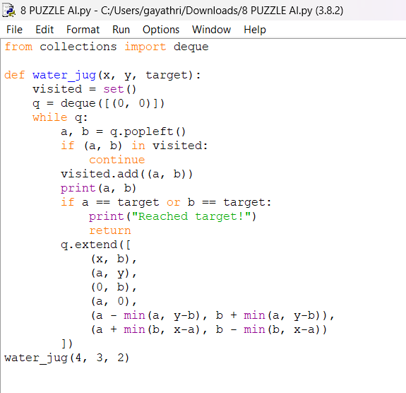

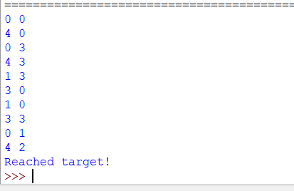

## **RESULT**

The program successfully solved the **Water Jug Problem** using BFS.  
 For jugs of capacity **4L and 3L** with target **2L**, the solution was reached at state (4, 2).